AGREEMENT FOR USE OF THE ACCREDITED CAB COMBINED ILAC MRA MARK
BETWEEN
NABCB AND ACCREDITED INSPECTION BODY
1. The International Laboratory Accreditation Cooperation (“ILAC”) Mutual Recognition Arrangement (MRA) Mark or the “ILAC MRA Mark” is registered and owned by ILAC in India having Trade Mark Registration Number 2892858.
2. The National Accreditation Board for Certification Bodies (NABCB), having its office located at 2nd Floor, Institution of Engineers Building, Bahadur Shah Zafar Marg, New Delhi -110002, has a non-exclusive and non-transferable license to use the Combined ILAC MRA Mark, subject to its maintenance of its ILAC MRA signatory status for Inspection, ILAC Accreditation Body (AB) membership and observance of conditions and restrictions set out in its agreement with the ILAC.
3. (NABCB Accredited IB’s full company name), having its registered / main office at (full business address), applies for permission to use the Accredited CAB Combined ILAC MRA Mark, only in conjunction with the NABCB Accreditation Symbol, subject to the terms and conditions set out below.
4. NABCB grants to the accredited IB permission to use the Accredited CAB Combined ILAC MRA Mark for accredited inspection activities covered in the scope granted by NABCB from the date of this Agreement, subject to the conditions and restrictions as follows:
(a) The NABCB accredited IB shall only use the Accredited CAB Combined ILAC MRA Mark (i.e. the ILAC MRA Mark in combination with the NABCB Accreditation Symbol) in the manner set out in ILAC-R7 “Rules for the use of the ILAC MRA Mark” as updated from time to time and in accordance with the inspection scope of the ILAC MRA of which the licensed ILAC MRA Member is a Signatory (herein case NABCB), and for inspections for which the IB has been accredited as per the scope of accreditation issued and for locations covered under NABCB accreditation. The use of ILAC MRA Mark alone by the NABCB accredited IB in any form is not allowed other than the Accredited CAB Combined ILAC MRA Mark.

(b) The NABCB accredited IB shall only use the Accredited CAB Combined ILAC MRA Mark strictly in accordance with the valid version of the NABCB procedure BCB 202 “Conditions for Use of NABCB Accreditation Symbol and other claims of accreditation, IAF MLA Mark and ILAC MRA Mark”;

(c) The ILAC MRA Mark shall be reproduced / printed, in black or white or in colour provided that the approved colours are used, according to the specifications and as per the rules set out in the valid version of ILAC R7 “Rules for the Use of the ILAC MRA Mark”.

(d) The permitted use of Accredited CAB Combined ILAC MRA Mark is non-exclusive;

(e) Permission granted to the NABCB accredited IB to use the said ILAC MRA Mark is non-transferable under any circumstance;

(f) The ILAC MRA Mark shall be positioned such that the it may be on either side (left or right), but shall appear in close proximity to NABCB Accreditation Symbol as depicted below:

ACCREDITED CAB COMBINED ILAC MRA MARK TO BE USED
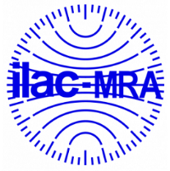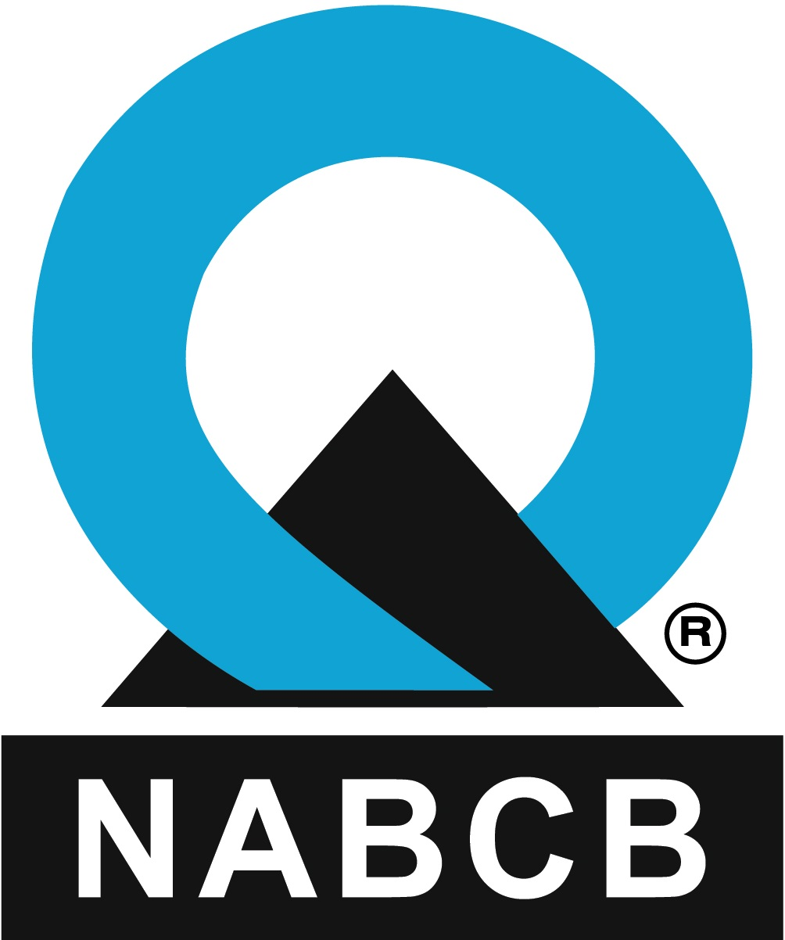
XX000

(g) The NABCB accredited IB shall not use the Accredited CAB Combined ILAC MRA Mark on any documentation other than as allowed in ILAC R7 and BCB 202.;

(h) The Accredited CAB Combined ILAC Mark shall only be used by NABCB accredited IB in economies where the ILAC MRA Mark is registered, or where an application for registration has been lodged and registration is pending.

(i) The NABCB accredited IB shall supply specimen of its usage of the Accredited CAB Combined ILAC MRA Mark to NABCB or ILAC, if requested by NABCB or ILAC;

(j) The accredited IB shall not use Accredited CAB Combined ILAC MRA Mark in such a way that it provides incorrect or misleading information on a product, or in a way that may be interpreted as denoting product conformity or in any way which implies that ILAC has approved a product, service or system inspected by the accredited IB;

(k) The NABCB accredited IB shall monitor and take suitable action to control its use of the Accredited CAB Combined ILAC MRA Mark and to prevent any incorrect references and document a procedure for same.

(l) The accredited IB acknowledges and agrees that it has no proprietary right, title or interest in the Accredited CAB Combined ILAC MRA Mark;

(m) The accredited IB agrees to co-operate fully and in good faith withs and/or ILAC for the purpose of securing or protecting ILAC's right in the Accredited CAB Combined ILAC MRA Mark;

(n) NABCB accredited IB shall not use the Accredited CAB Combined ILAC MRA mark in any way that would harm the reputation of ILAC and/or NABCB.

5. The Agreement to use the Accredited CAB Combined ILAC MRA Mark shall be terminated in the following conditions:

(a) at any time by agreement of the parties;

(b) at any time in the event that the conditions in this Agreement are not satisfied;

(c) immediately on expiry of NABCB accreditation or in case it is not renewed by IB;

(d) immediately in the event the NABCB accreditation of IB is withdrawn or suspended for whatever reason;

(e) immediately in the event of suspension or termination of the NABCB’s ILAC MRA signatory status or ILAC membership;

(f) immediately in the event of the termination of the Agreement for the use of the ILAC MRA Mark between ILAC and NABCB;

(g) by the NABCB duly advising the accredited IB; or

(h) by the ILAC duly advising NABCB or the NABCB accredited IB.

6. The NABCB accredited IB shall indemnify and save NABCB and/or ILAC, its directors, officers, employees and authorized representatives from and against any and all claims, liabilities, demands, proceedings, causes of action, costs and expenses (including legal fees as incurred) arising from the breach or default of the NABCB accredited IB under this Agreement.

7. All disputes, if any, arising of this agreement, that shall remain unresolved through dispute redressal mechanism provided by NABCB, are subject to exclusive jurisdiction of the Courts at New Delhi and none other.

Signed on behalf of (Name of accredited IB)
Name:
Designation:
Date:

Signed on behalf of National Accreditation Board for Certification Bodies (NABCB)
Name: Chakravarthy T. Kannan
Designation: Chief Executive Officer
Date:

